Task 3:

Configuration of basic switch setup using Huawel/Cisco network switch using cisco packet tracer.

Procedure:

Step 1: Setting Up the Network Topology

1. Open Cisco Packet Tracer
2. Add devices:

* Drag and drop a Cisco switch onto the workspace.
* Drag and drop two or more switch using the FastEthernet ports(e.g., PC0 to FastEthernet0/1, PC1 to FastEthernet0/2)

Step 2: Connect devices:

1. Open the CLI of the switch:

* Click on the switch and go to the CLI tab.

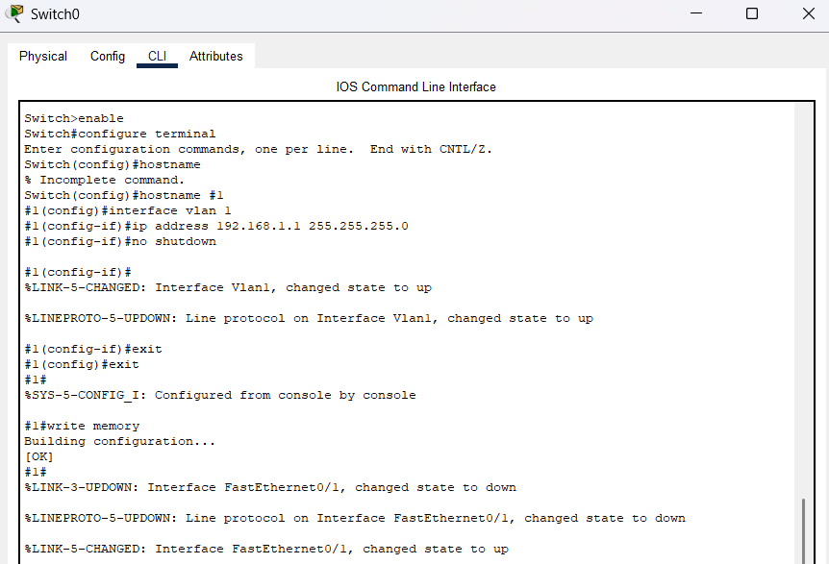

**Router Configuration process:**

**1. Enter privileged EXEC mode:**

Switch> enable

Switch#

**2. Enter global configuration mode:**

Switch# configure terminal

Switch(config)#

**3. Configure the switch hostname (optional):**

Switch(config)# hostname s1

S2(config)#

**4. Configure VLAN 1 (default VLAN) interface with an IP address**

S1(config)# interface vlan 1

S1(config-if)# ip address 192.168.1.1 255.255.255.0

S1(config-if)# no shutdown

S1(config-if)# exit

S1(config)#

**5. Save the configuration:**

S1(config)# exit

S1# write memory

Step 3: Configuring PCs

1. Assign IP addresses to PCs:

* Click on each PC and go to the **Desktop** tab.
* Open the **IP Configuration** and assign an IP address within the same subnet as the switch’s VLAN 1 interface.
  + **PC0**: IP Address: 192.168.1.2, Subnet Mask: 255.255.255.0
  + **PC1**: IP Address: 192.168.1.3, Subnet Mask: 255.255.255.0

Step 4: Testing Connectivity

1. Ping between PCs:

* Open the Command Prompt on one of the PCs (e.g., PC0).
* Use the ping command to check connectivity to the other PC (e.g., ping 192.168.1.3).

